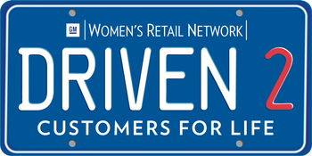
PES #3: DRIVEN2 BUILD
Leveraging CSI/SSI to Improve the Customer Experience
Kristin Sowle, Senior Director, U.S. Automotive Sales, J.D. Power

Elevating the Customer Experience
- The pace of SSI and CSI score growth is slowing, which suggests customer expectations are changing just as quickly as dealers are improving.
- Leveraging SSI/SCI data helps dealers to:
  - Understand customers to better satisfy them
  - Increase retention
  - Drive positive word-of-mouth advertising, referrals, reviews
- Customer expectations are influenced—if not defined—by all customer experiences across all industries.
- Objective: Identify, translate, and implement best practices from iconic brands across industries to elevate the automotive customer experience.
- The dealership experience is being judged against leading brands across all industries.
- Savvy dealers are looking to retail leaders outside of automotive for customer experience best practices.
Examples:
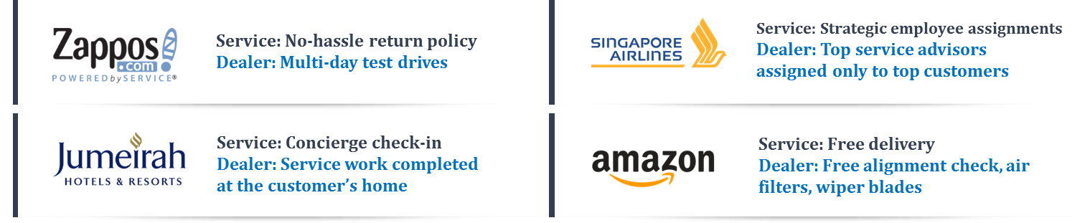

Using CSI/SSI to attract female buyers
- Females are more likely to reject a dealer due to the treatment that they receive
- In order to attract female buyers, dealers need to close key customer experience gaps between male and female buyers
  - Specific areas to focus for female buyers in the sales process are: demonstrating features at delivery, straightforward price quotes, contact after sales and delivering vehicles without issues
  - Specific areas to focus for female customers in service are: Service advisors focused on customer needs and providing helpful advice, consistency of fixing vehicles right the first time
- Dealership facility and amenities are areas that can be focused on across both sales and service.
  - Availability of magazines targeted toward a female audience, variety of beverages offered including bottled water, TV programming and channels that are of interest to female customers
Customer Empowerment: “Me”-tailing
Individualized Buying/Ownership Experiences
Understanding that purchasing the desired product or service is only part of the experience, businesses are responding by delivering personalized experiences designed to meet each individual’s unique needs. Dealers who ignore this CX evolution will be challenged by non-traditional competitors.
Actions:
- Customize the shopping experience so that it is unique and one-of-a kind is highly desirable – particularly since most items bought are not unique
  - Example: Top service advisors assigned to specific customers, utilized as their point-person for all service related inquires on their vehicle
- Use service to create a unique experience on an activity that can be otherwise lacking in noteworthiness
  - Example: Multi-day test drives, customer can take the vehicle to use for 2-3 days before they make their purchase decision
- Create individualization of services to turn a “painful” activity, or one perceived as a commodity, into a unique greater value experience
  - Example: Offering concierge service where loaners are dropped off at the customers home/work and their vehicle is picked up and taken in for service
People, Process, Technology: Three Components to an Elevated Customer Experience
People
- Empowered and committed, Engaged, Trustworthy and Credible
- Stop turnover, costing operations $3B
- Hireology -- end-to-end hiring process that helps dealers reduce turnover, save time and money, and protect your bottom line.
Process
- Consistent and measureable, Aligned with customer NEXTpectations
- Product parity is increasingly the rule; Now more than ever, customer experience is a leading differentiator in automotive.
- Savvy dealers are looking to retail leaders outside of automotive for customer experience best practices.
  - Four Seasons Example: Supply employees with a “Get out of jail free” cards, which empower staff members to make on-the-spot decisions to resolve concerns and satisfy customers.
  - Dealer Example: Empower employees to make reasonable, yet meaningful, decisions to resolve customer concerns and cultivate long-term satisfaction and loyalty.
Technology
- Reduce customer time and effort, increase operational efficiency, support cross-channel experiences
- Dealers must embrace technology, particularly with Gen Y
    - Example: New web feature allows the customer to fill out their finance pre-qualification online before visiting the dealership
    - This makes it more efficient for the customer to fill out the document, means less time taken up for sales staff and promotes usage of the dealer website
Summary
1. Customer expectations are evolving at a rapid pace
- Personalization and technology are driving higher customer expectations
- Expectations are driven by experiences both in and out of the automotive industry
2. The technology piece is key for both increased satisfaction and profitability
- This is particularly true among Gen Y who tend to adopt technology at higher rates and are less satisfied with their automotive experiences
3. A robust system for analyzing and reacting to customer data needs to be in place to consistently deliver a superior customer experience
- This should include solicited and unsolicited data as well as transactional and relationship feedback

