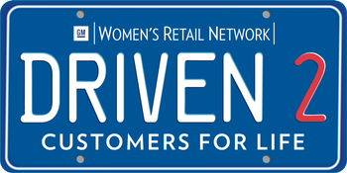
PES #5: DRIVEN2 REACH
Win Over Your Customers with the Right Fixed Ops Experience
Kim Saylor, Product Marketer of Fixed Operations, CDK Global
- Leverage new trends in mobile to increase service work
- Provide information to your customers to allow them to make the best decision during their
service experience
- Keep more of your service customers by giving them the experience they expect
- Reverse the trend: New car dealers have 13% of overall service market

1: Schedule 1st service appointment
Problem: New and used sales customers leave the dealership without scheduling first service appointment.
Customer intent to return to selling-dealership for service:
- 38% would return without a first appointment
- 57% would return if you set the first appointment
- The easiest way to schedule appointments is to have an integrated system so that the process is simple for the salesperson.
2: Send service reminders
Problem: Nearly 70% of dealers don’t send out service reminders
- 31% send out reminders
- Send automated reminders using the customer’s preferred method (phone/email/text).
3. Connect with consumers in their moment of need: “Micro-Moments”
Problem: Dealers don’t have the right digital tools in place to reach customers.
- 82% of Smartphone users turn to a search engine when looking for a local business
- 2X: Increase in “near-me” search interest
- Properly identify, implement and measure a digital process that maximizes dealership promotion/connection/attraction with customers
4. Mobile trends are driving service research online: Show Up!
Problem: Dealers aren’t getting the best search engine results/don’t show up on customer searches.
- 43% of drivers perform a search on their phone or online when deciding where to take their vehicle for service.
- It’s critical to connect with drivers whenever and wherever they’re searching for their next service, using whatever criteria: nearest, cheapest, best review, brand, hours, et al, and whatever device: mobile phone, tablet, and computer.
- See #3
5. Offer online appointment service
Problem: Dealers aren’t offering/maximizing online appointment scheduling
- 79% of customers have or would book a service appointment online.
- Online appointment scheduling is one of the requirements for GM’s EBE incentive program. Select a solution that integrates with the dealer’s DMS (or appointment system). This eliminates the redundancy of maintaining appointments and appointment capacities in multiple places.
6. Offer bundled services
Problem: Dealers aren’t offering/maximizing bundled services.
- Bundled services appeal to customers, such as maintenance packages:
  - Oil Change
  - Rotate Tires
  - Replace Wiper Blades
  - Wheel Alignment
- Other brands/businesses offer bundled services, such as Amazon, by packaging items customers bought based on their shopping history
- The dealer benefit is selling multiple services. This can be done using a Service Price Guide tool. Some DMS providers may also use dealership op-codes.
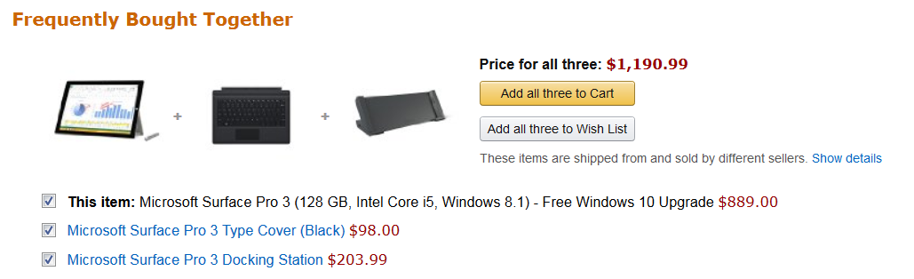

7. Erase customer perception barrier of dealership service
Problem: 63% of consumers say that independent service centers are as good as dealership service centers when it comes to fixing vehicles.
- 58% of consumers say dealer service centers are not price competitive with independent service centers
- 81% of drivers agree that quality service is more important than price
8. Improve customer welcome/interaction with appropriate technology
Problem: Not all service advisors taking advantage of tech tools to improve service/customer experience.
- Dealers using tablets during the write-up process are seeing revenue increases up to 20%.
- Another suggestion is using RFID technology; welcoming the customer on a welcome board when they drive into the service lane.
9. Offer various service options
Problem: Dealers aren’t offering/maximizing service options.

- Replace Engine Oil & Filter
- Rotate Tires
- Inspect Brake System
- Inspect Wiper Blades
- Top off all Fluids
- Replace Engine Oil & Filter
- Rotate Tires
- Inspect Brake System
- Inspect Wiper Blades
- Top off all Fluids
- Inspect belts & hoses
- Replace Air filter
- Inspect Cooling System

$59.95

$99.95
$219.95
- Replace Engine Oil & Filter
- Rotate Tires
- Inspect Brake System
- Inspect Wiper Blades
- Top off all Fluids
- Inspect belts & hoses
- Replace Air filter
- Cooling System Flush
- Inspect Exhaust System
- Inspect Undercarriage for damage & leaks
- Customers want the freedom to make choices: services, price points.
- The easiest/most effective way to offer options is to utilize a tool that integrates into the total system, so when a customer chooses a package it rolls right onto the repair order. If the dealer doesn’t have a tool, a paper menu is a cost-effective option.

10. Increase repair order revenue.
Problem: Dealers not taking advantage of all opportunities.
- There is a significant increase in closing additional work when the vehicle is in the air.
  - Average R.O. from 1.5 to 3.5 CP Hours
  - 37% Typical closing rate if a vehicle is not on a lift
  - 56% average closing rate if a vehicle is on a lift
- Another example to increase RO revenue: Provide the consumer with information to make an educated decision on the work that is being recommended. This may include a description of the repair, why it’s necessary and photos.
11. Eliminate use of personal phones for customer calls.
Problem: Employees use their personal cell phones for business calls and texting customers 90% of the time.
- When this happens, dealers have no way to measure or monitor these interactions
- Solution: Provide employees business phones.
12. Make the S&P payment experience more convenient.
Problem: Not all dealers taking advantage of tools for customer convenience and service efficiency.
- Allow customers to specify a pick up time for parts or their vehicle
- The easier the payment process is, the more dollars customers will spend
  - In-store cashiering -- accept all forms of payment
  - Notify key personnel of payment
  - Collect electronic signatures
  - Maintain flexibility with remote, desktop and mobile
  - Mobile Cashiering
  - Service & Parts Advisor Desktop
- The biggest benefit will be customer’s convenience and dealership efficiency, but it may also save a dealership money.
13. Repeat cycle every time: Make it part of your process.
ALWAYS SCHEDULE THE NEXT APPOINTMENT AT THE CONCLUSION OF THE CUSTOMER TRANSACTION.
Percentage of customers who would return for their next car purchase when you follow this workflow:
